Steps followed after installing the NCPA agent - active check on Nagios Core 3.5.0
1.Check command declaration in Nconf:
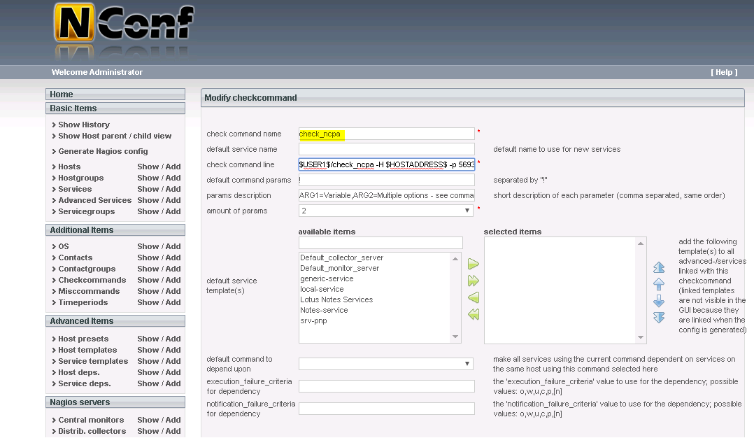

2.Creating New service by setting the check command called check_ncpa and given the following parameters below.
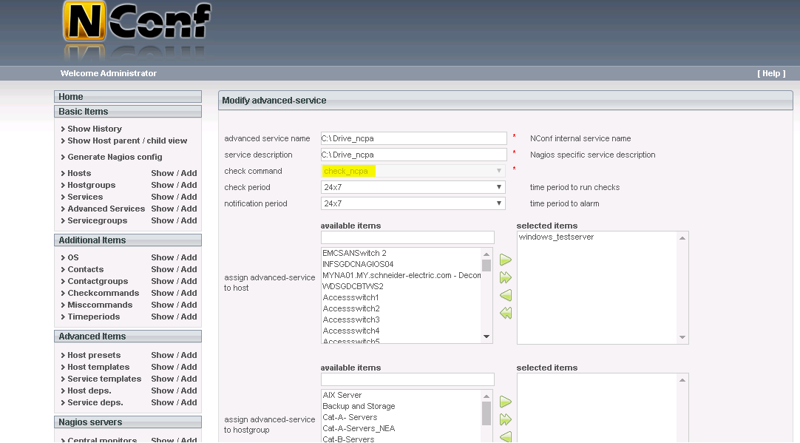

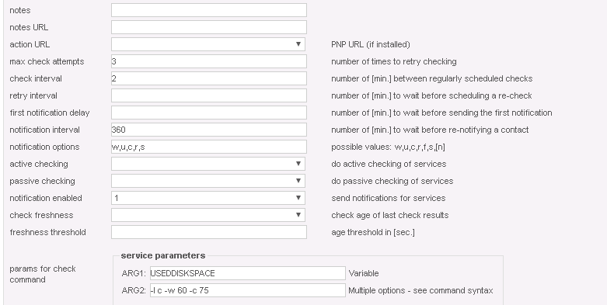

3.Finally add the service to the host to monitor via NCPA

4. On Agent side configuration, I have installed the application NCPA Agent and specify the token that was created from the Nagios server end.

