First scenario :

The second host in not visible in the host group and services are not working on other hosts.

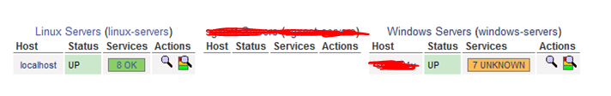

Second scenario :

The second host is not visible in the host group and services are working on other hosts.

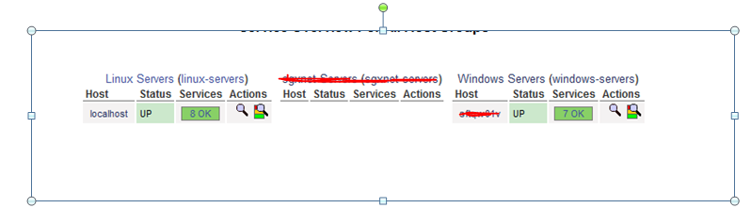

Third scenario

Everything has been working but after next refresh it won’t be working Like above example.


