ip addr:
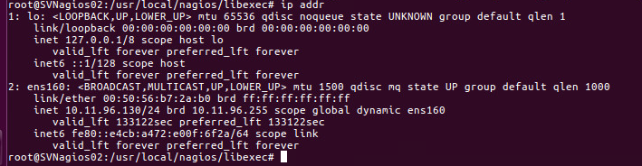

/usr/local/nagios/bin/nrpe:

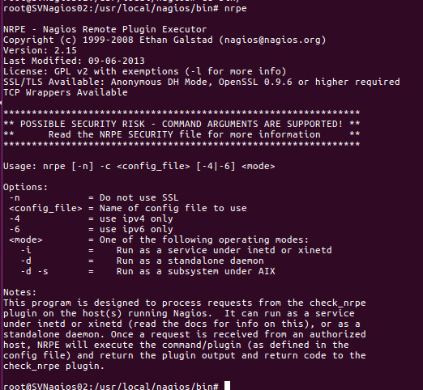

/usr/local/nagios/libexec/check_nrpe -H <windows server ip>
